China high quality golf stand bag
1 Wear Resistance: Made of polyester fabric, this golf shoulder bag is sturdy enough to avoid any additional wear and tear while using it. It surely guarantees you a durable lifetime for its sturdy construction and a longtime satisfactory experience.
2 Premium Travel Helper: It is quite great for traveling for it takes up very little space in a trailer, camper, or car trunk due to its compact body. You can just take it to your desired place effortlessly. And the bag can be stored neatly when you do not use it.
3 Foot Support: With a total color of black and aluminum paint foot pipe support, it can stand steadily and balanced as you want to release your hands. And it can also stand straight with a plastic chassis. A rubber foot pipe bracket can well prevent the scratch.
​
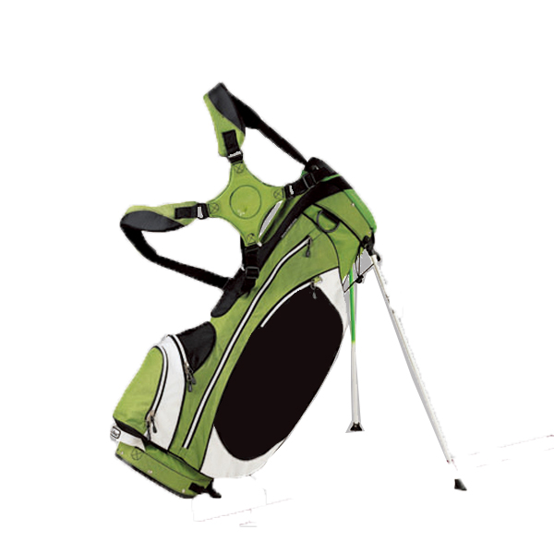
More information please click: www.tt-golf.com

